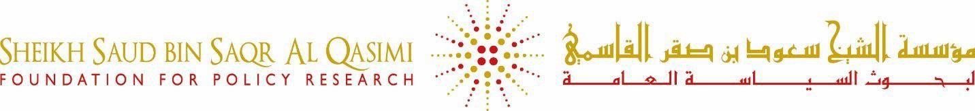

Al Qasimi Foundation Position Overview:

# Intern for Arts and Culture Department

**ABOUT THE AL QASIMI FOUNDATION**

The **Sheikh Saud bin Saqr Al Qasimi Foundation for Policy Research** was established in 2009 to support the social, cultural, and economic development of Ras Al Khaimah and the United Arab Emirates (UAE). The Al Qasimi Foundation seeks to support the public and private sectors by helping them with ground policy decisions and programming evidence-based research that reflects the best thinking in the world as well as the local Ras Al Khaimah and UAE contexts. Our work over the past 10 years has focused on generating world-class research, developing local capacity, and engaging the local community. While we continue to have a strong focus on improving education, we have also expanded our priority areas to include health, community development, arts, and culture and we have extended our reach to target groups that are particularly disadvantaged such as those in prison, low-income students and their families and those in the remote areas of Ras Al Khaimah.

# POSITION OVERVIEW & SCOPE

We are looking for an intern to work within the Arts & Culture department to assist our Senior partnership specialist. This internship will be heavily administrative and require a candidate with strong attention to detail skills and excellent time management.

# RESPONSIBILITIES

1. Wrapping up the partner success reports.
2. Helping put together partnership decks for key initiatives across the Foundation.
3. Supporting the Partnership Committee with meeting prep, materials, and follow-ups.
4. Brainstorming and drafting a visitor engagement package for the festival.
5. Assisting with RAK Art 2026 partnership planning and document preparation.

**SKILLS & QUALIFICATIONS**

|  |  |
| --- | --- |
| Document and information management skills | Advanced |
| Strong planning, organizational and time management skills | Advanced |
| Attention to detail and accuracy | Advanced |

|  |  |
| --- | --- |
| Strong interpersonal communication skills and the ability to work effectively with a wide range of people from diverse backgrounds | Intermediate |
| IT skills | Intermediate |